Why Mechanical Properties?

* Affects what kind of materials you can use for different applications and how you should use them. For example, when you build a bridge you want to know how much the material, especially metals will expand or contract depending on weather.

**Deformation of Material:**

1. Tension
2. Compression

-Both of the above change the shape and volume of the material

- Same but in opposite directions. According to convention Tension is (+) and compression is (-)

1. heer
2. Hydrostatic Compression

**Stress and Strain:**

* *Stress:* pressure due to applied lead
$$σ=\frac{force}{area} \left(\frac{N}{m^{2}}\right)or P$$

* When $σ<0$ then it is compression, if $σ<0$ then it is tension.
* Stress is more directly conntected to material properties than force
* *Strain:* response of the material to stress

Examples: hydrostatic compression – fish in liquid

* Strain $∈=\frac{l_{i-l_{o}}}{l_{o}}=\frac{∆l}{l_{o}}$

*lo*

*li*

Figure 1: the lengths needed to calculate the strain on of a system

Common states of stress:

* Simple tension: cable
* Simple compression: bridge
* Hydrostatic compression: a fish is always squished

3. Sheer

Pure Sheer stress: $τ=\frac{F}{A_{o}}$

Pure sheer Strain: $γ=tanθ$ always dimensionless

θ

Figure 2: The strain diagram

**Elastic Deformation:**

1. Initial configuration

2. Small load - stretch

3. Unload – return to initial configuration

*l0*

*σ*

Figure 3: elastic deformation

**Plastic Deformation:**

1. Initial configuration

2. Small load - stretch

3. Unload – but keeps plastic deformation

*l0*

*σp*

*σp + σe*

Figure 4: plastic deformation

elastic

plastic

Figure 5: when the material is under plastic deformation, it does not regain its original shape; it is left with some *plastic* deformation

**Ultimate Tensile Strength:** for a typical metal

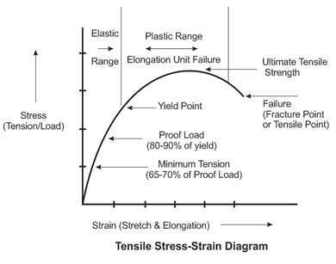Figure 6: A UTS curve, showing stalbe, ultimate, and failure stages (<http://www.lpsindia.com/strength-characteristics-details.aspx>)

Drawbacks of UTS:

* It is only appropriate for ductile materials (metals) not good for brittle materials (ceramics)
* For Brittle materials, UTS is not a material property, it is a measure of the strength of the biggest flaw.

1

2

3

Figure 7: Shows the stages of the UTS diagram. (1) is the stable plastic deformation (2) necking, the white part will now have a constant deformation – blue part has concentrated deformation (3) past UTS

BRITTLE:

1

2

Figure 8: For each of the labeled section (1) and (2), the UTS is determined by the biggest flaws, and the flaws are randomly distributed which means that (1) and (2) create different results.

**Related Materials:**

UTS

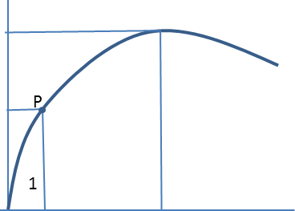 Fracture

Figure 9: (1) is elastic, and Point P is the yielding strength $σ_{y}$, it is the onset of plastic deformation. I is the point where the material yields, this is not a very well defined point.

High UTS More resistance till failure

High $σ_{y}$ Resistance to permanent deformation

**Elastic Modulus (Younq’s equation):**

$σ=Ee$ strain

Stress modulus (slope in elastic region)

-Shear modulus: τ = Gy

With $G= \frac{E}{2(1=v)}$

-Bulk modulus: $P=-K\frac{∆v}{v_{0}}$

With $K= \frac{E}{3(1-2v)}$

E,G,K > 0

**Poisson Ratio**

Z tension , $ε_{z}= \frac{∆l}{l_{0}}$

x :compression, $ε_{x}= \frac{∆d}{d_{0}}$

Isotropic x and y, $ε_{y}= ε_{x}$

Metals ~ 0.33 ; ceramic~0.25 ; polymer~0.4

Poisson’s ratio = $v= \frac{-ε_{x}}{ε_{z}}= \frac{{-ε}_{y}}{ε_{z}}$

**True strain/stress :**

$σ_{T}= \frac{F}{A_{T}}$

instantaneous area

$ε_{T}=\ln{(\frac{l_{i}}{l_{0}}})$ intantaneous lenght

$ε= \int_{0}^{t}{\frac{dl}{l_{0}}}$

Maximum stress point decreases then:

-Material weaker

-smaller necking crossectional area. $A_{0}vs A_{T}$

Stress

True

Engineering

Strain